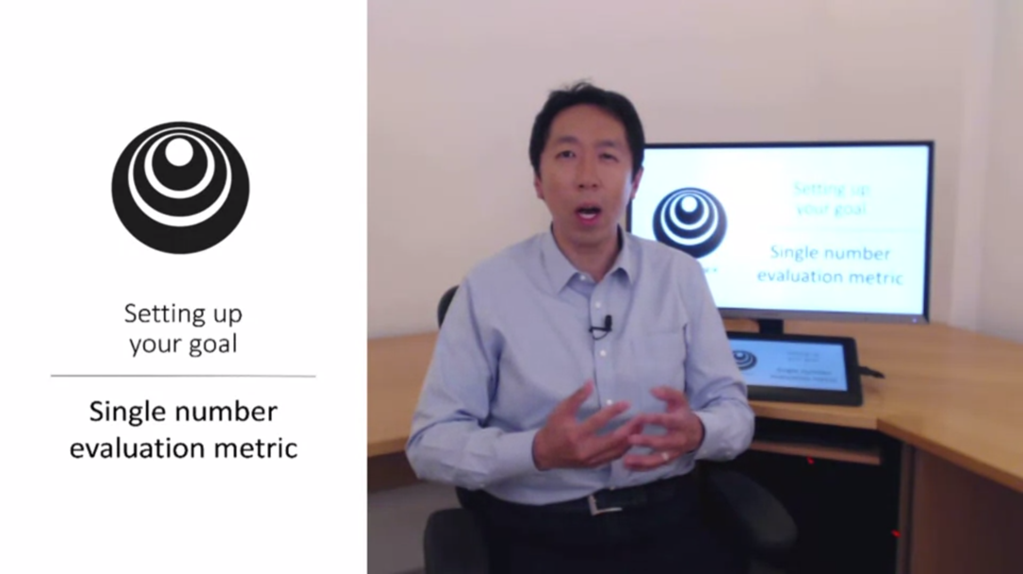

When you try out different things to improve your solution it is very useful to have a single number evaluation metric. Andrew recommends to set this up at the beginning of a ML project.

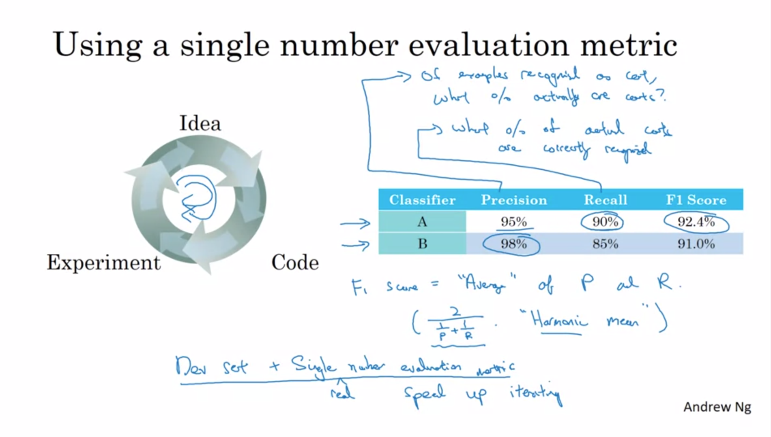

Example: first trained classifier A, then tuned some hyperparams to train classifier B.

Precision and Recall are metrics to evaluate this classifier. We care about both in this case. It might be reasonable to evaluate the classifier in terms of both then. How can we do that? We define a new evaluation metric that combines precision and recall. In the ML literature the standard is the F1 Score. Informally you can think of this as the average between precision and recall. In terms of math this is the harmonic mean.

This also scales to multiple classifiers.

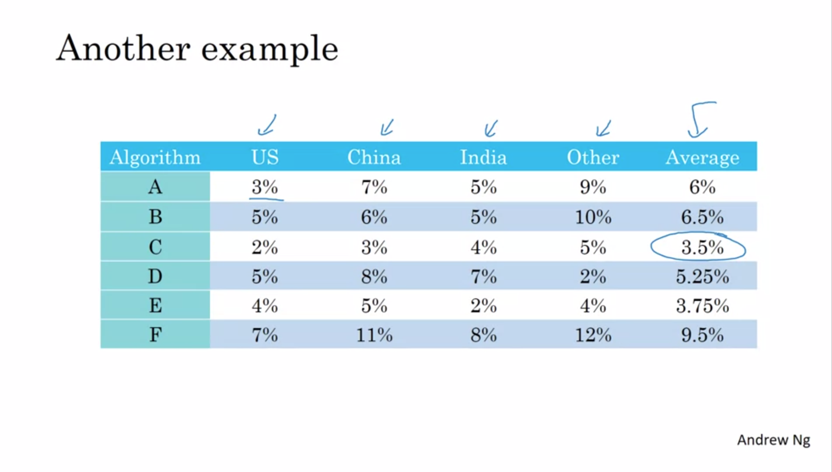

Another example: let’s say we have build a cat classifier for different regions. The average could be a reasonable evaluation metric.

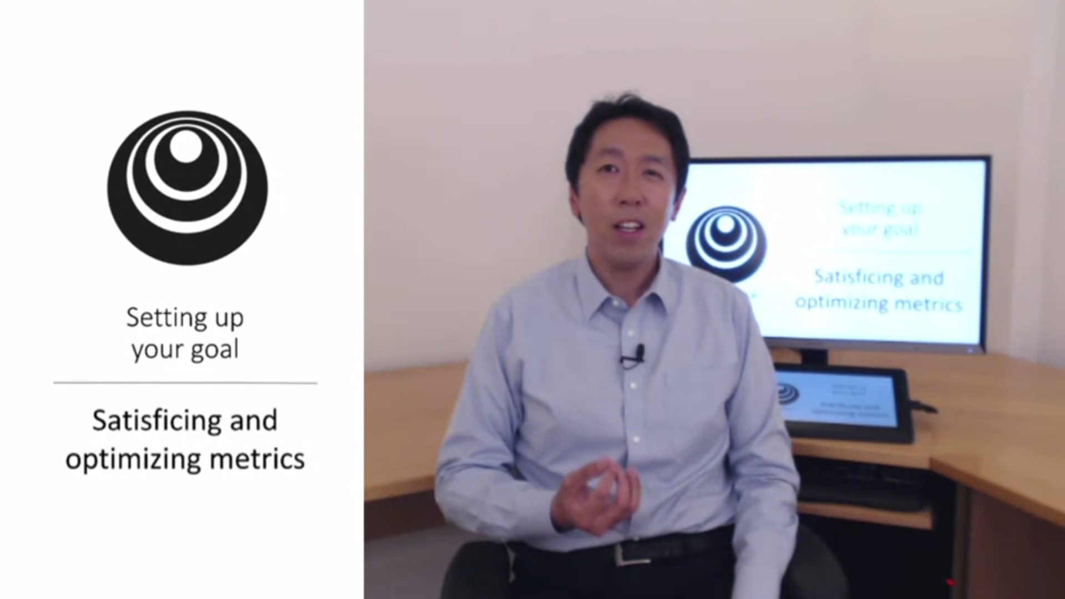

It is not always easy to combine everything you care about in a single evaluation metric. In those cases you can set up satisficing and optimizing metrics.

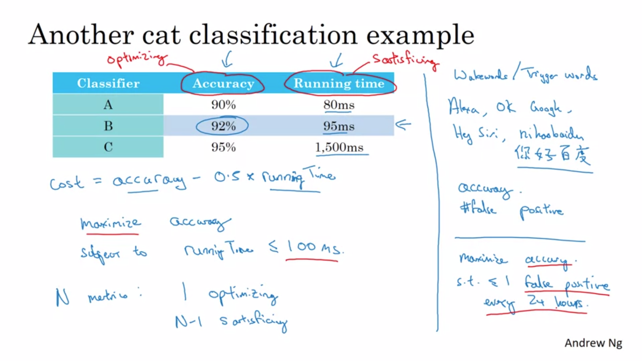

One thing you could do is combine accuracy and running time into on metric. Maybe this seems a bit artificial. The other option is you maximize one, subject to the other.

False positive here: the system wakes up without anyone saying the trigger word.

These evaluation metrics must be calculated on a train/dev/test set. We need to set these up. Andrew has some guidelines for that.



A good setup is very important for rapid progress.

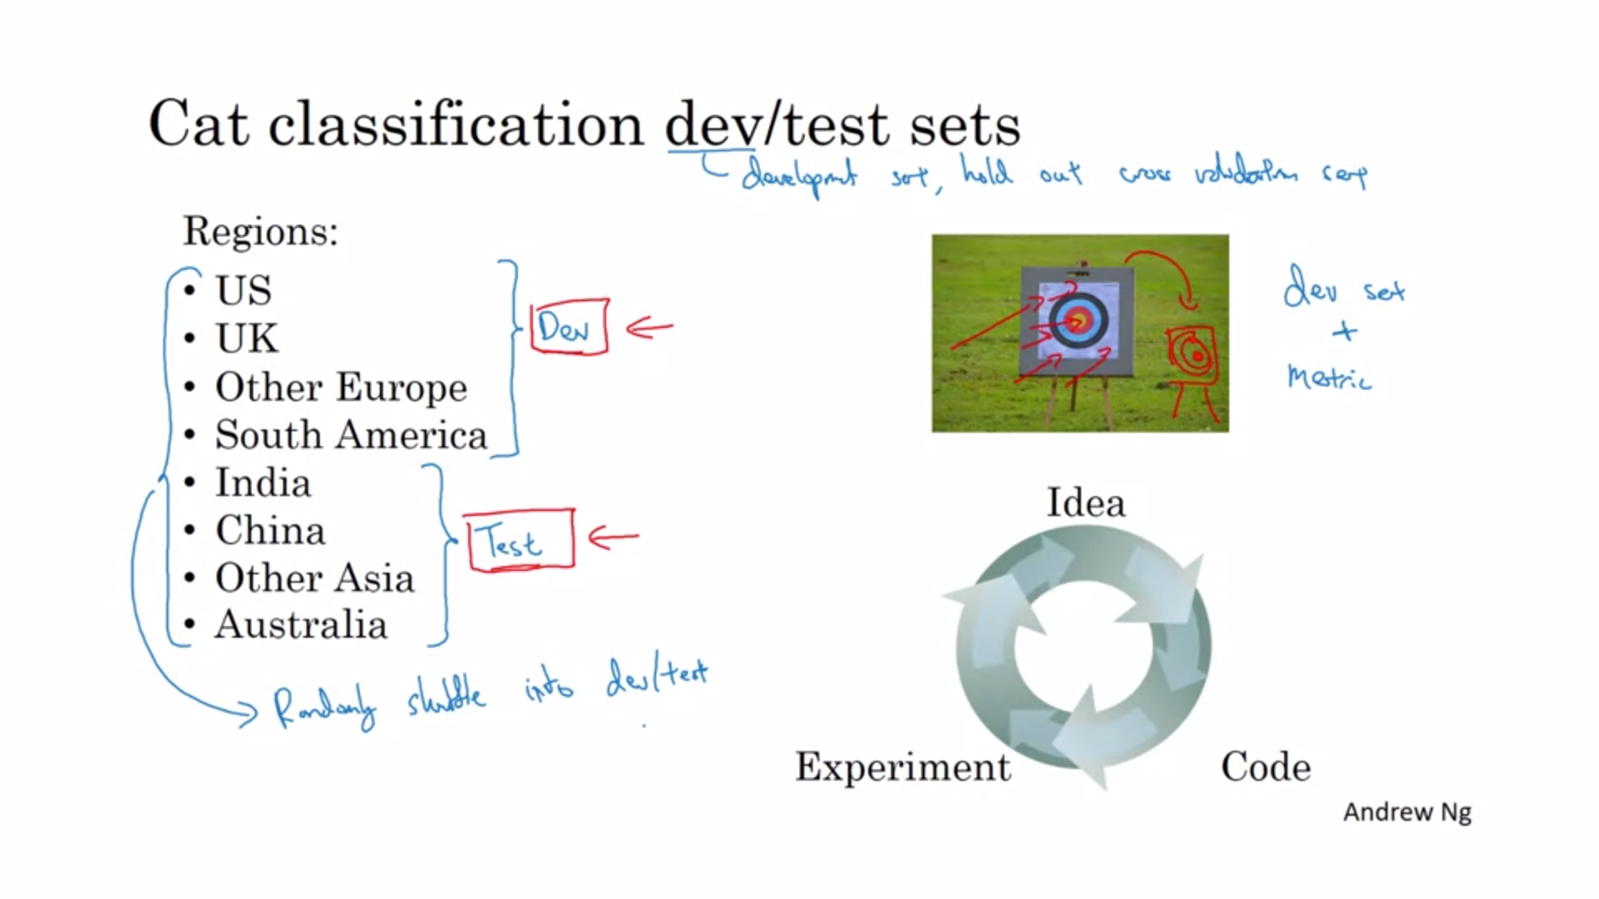

One way you could setup the sets here would be to split according to regions. This is NOT a good idea. The dev and test set should come from the same distribution.

If you spend a lot of time optimizing to the dev set but the test set comes from a different distribution, then it might not perform well on the test set. Instead you should randomly shuffle the data.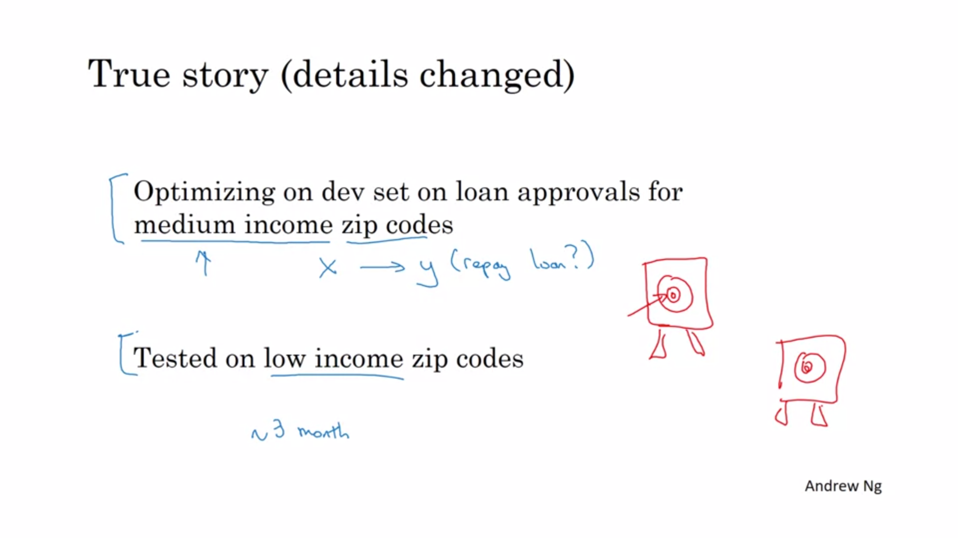

Distribution of data between medium and low income is very different.

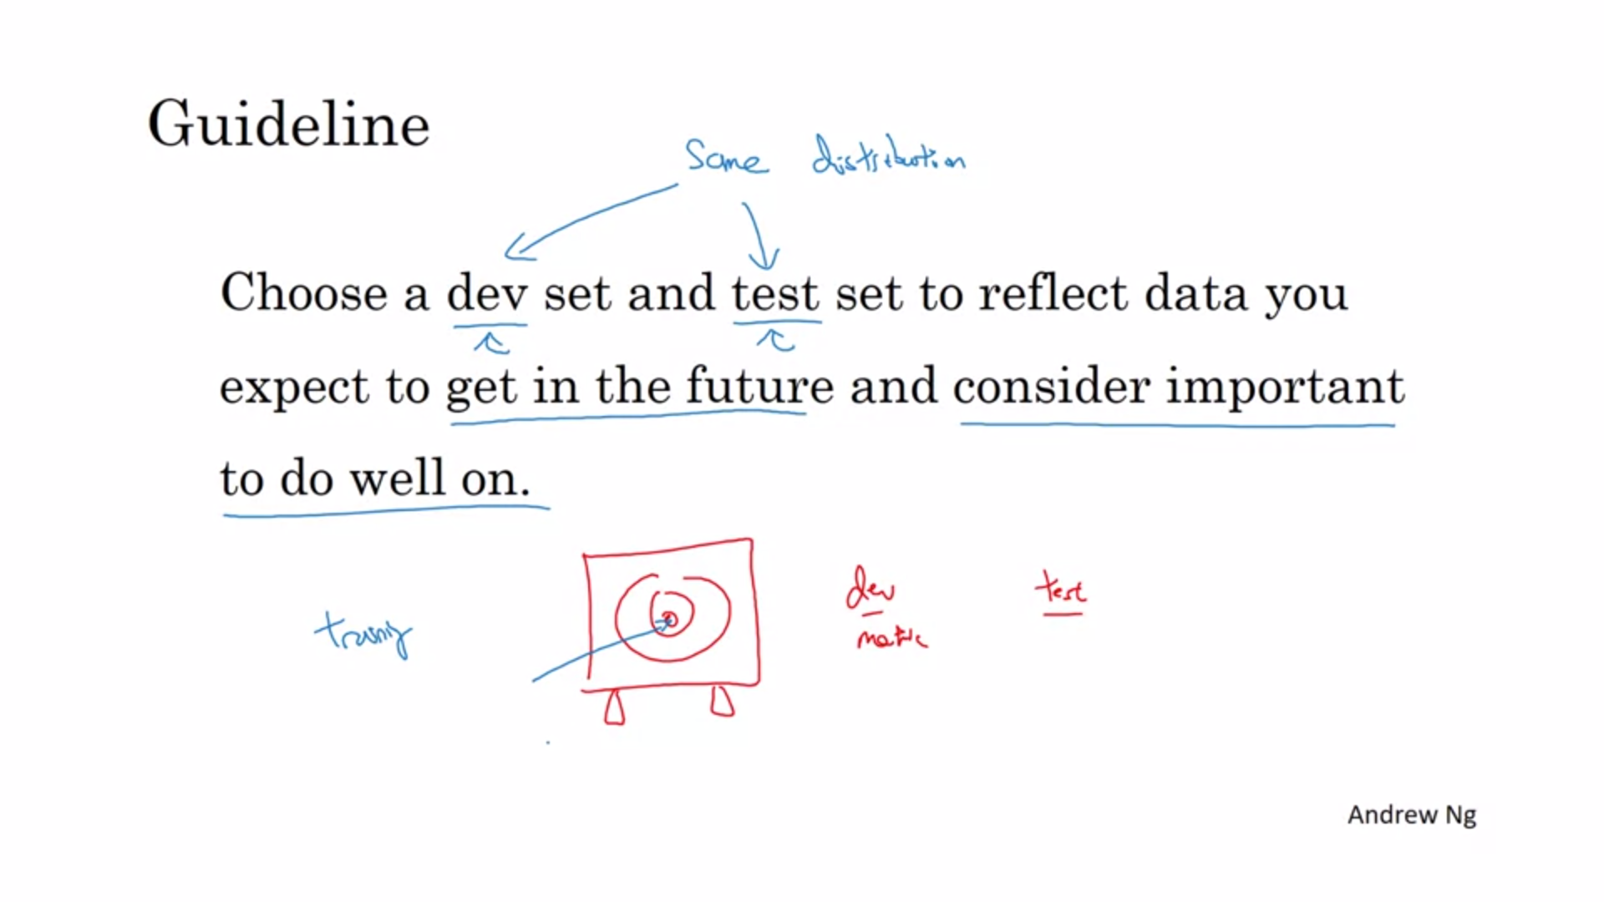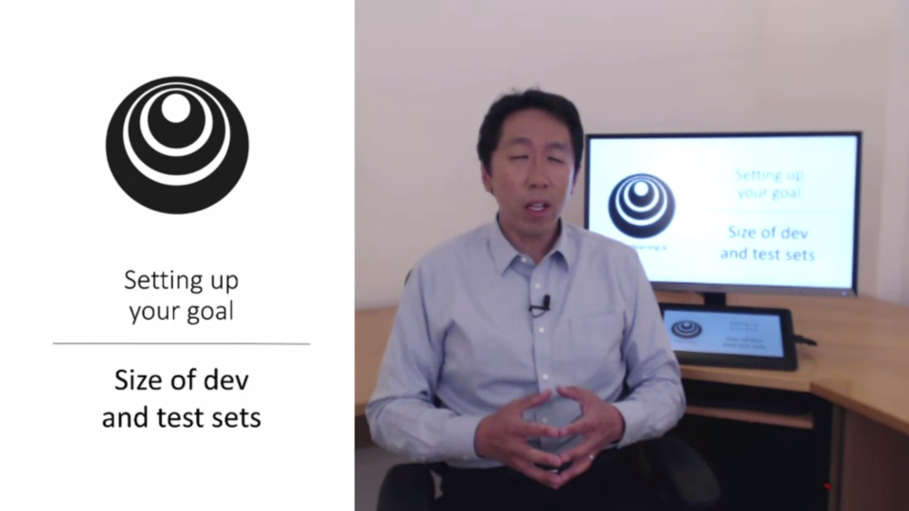

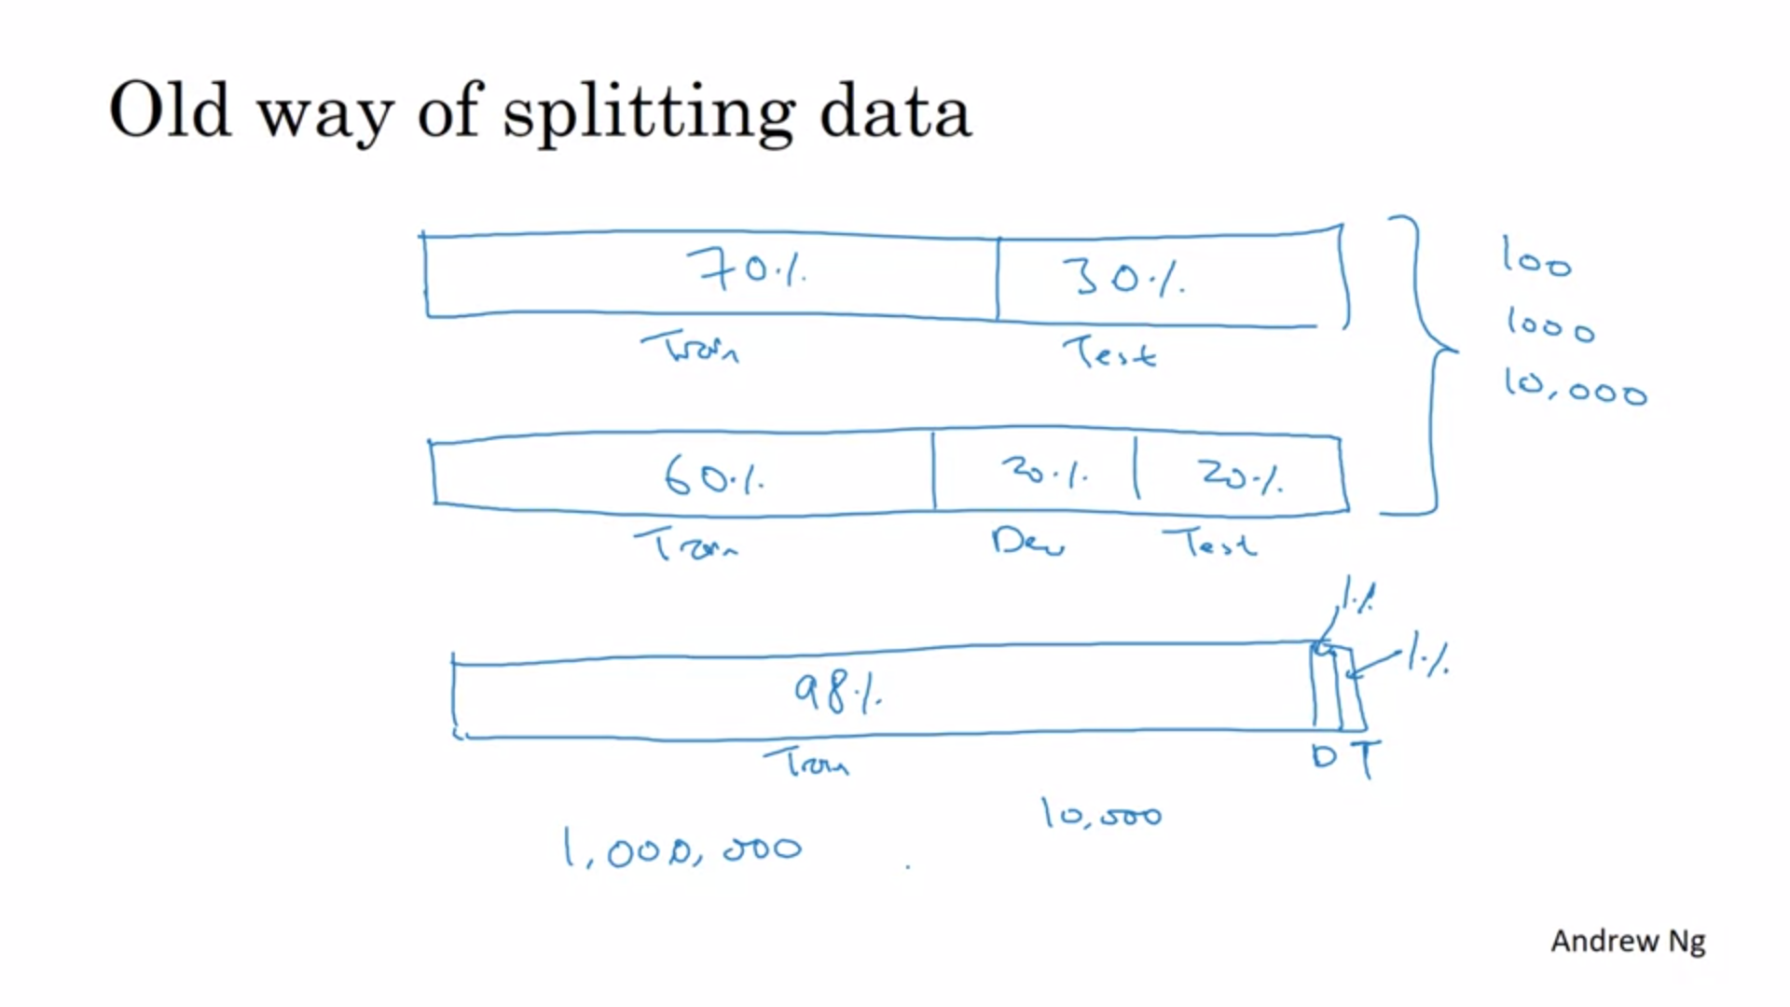

70-30 or 60-20-20 was the rule of thumb in traditional ML (when we had less data).

Now with lots of data it is more reasonable to use 98-1-1.

The test set is “only” needed to assess the confidence in the final performance of the system.

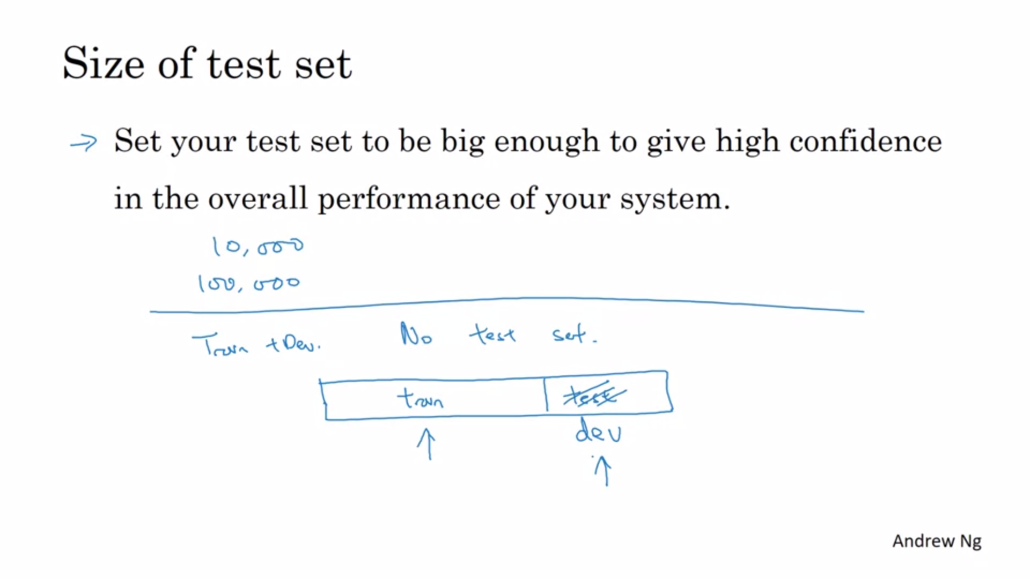

Not having a test set might be ok.

Some people confuse the terminology and are not very rigorous between dev and test set.

Andrew is not recommending to not have a test set.

The sets should be the right size to serve their purpose.

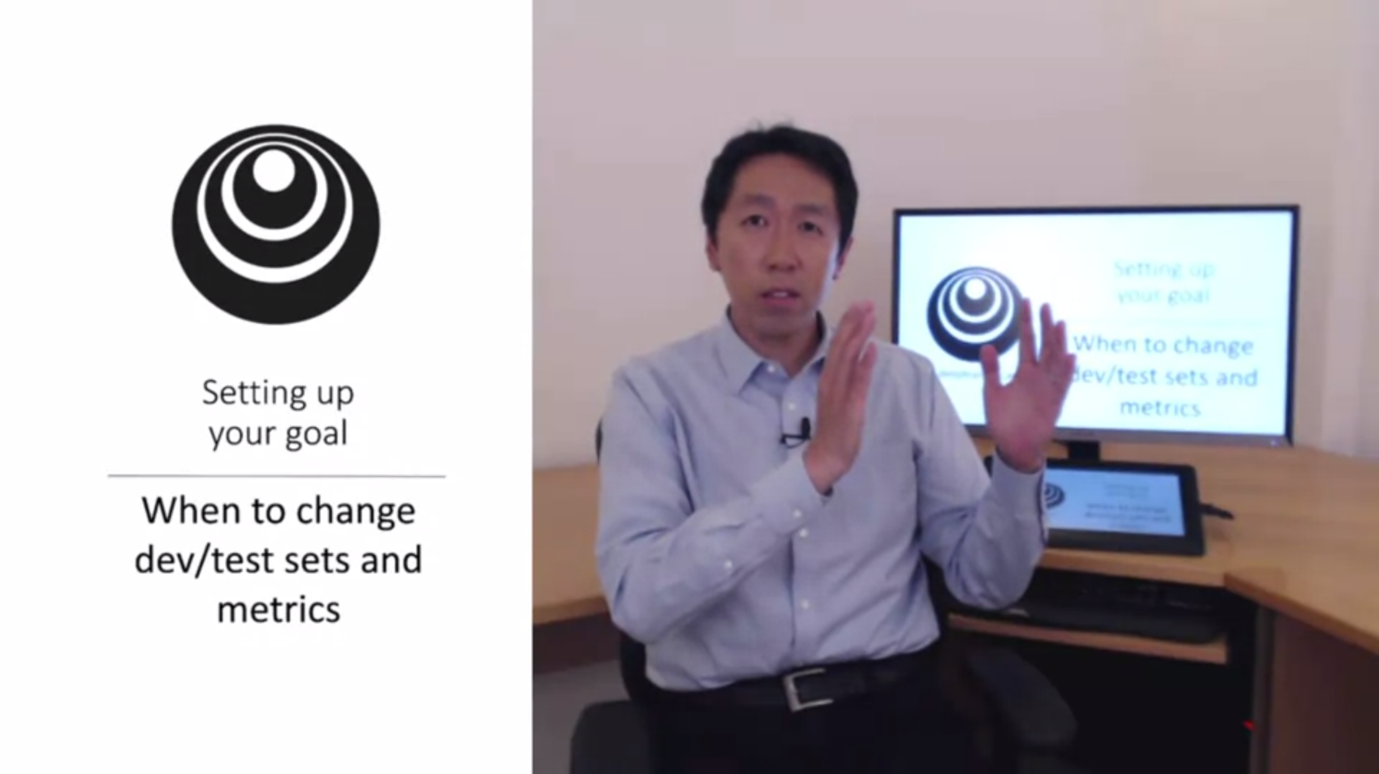

Sometimes halfway through the project you realize that you have misplaced your target. In that case you should move the target.

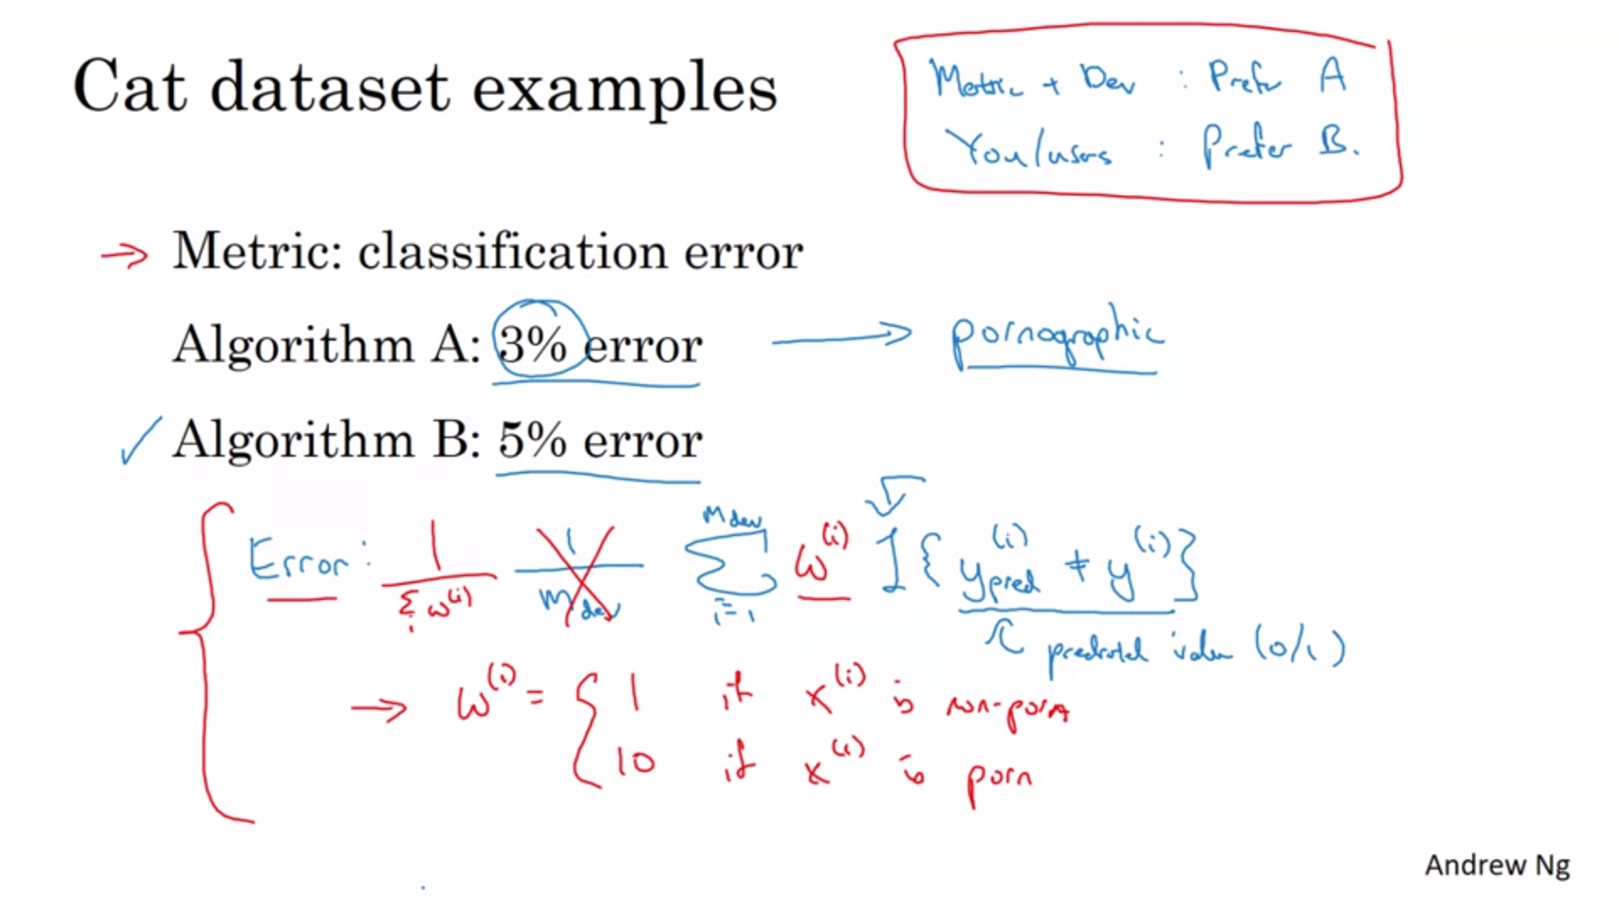

Example: Algorithm A has the better metric but let’s through a lot of pornographic images. This is totally unacceptable for the company and the user.

This means that the evaluation metric is not correctly rank ordering the classifiers anymore. In this case we should change the metric. We can add a weight term w(i) to account for pornographic content (10 times bigger weight). Also normalize so that it still adds up to 1.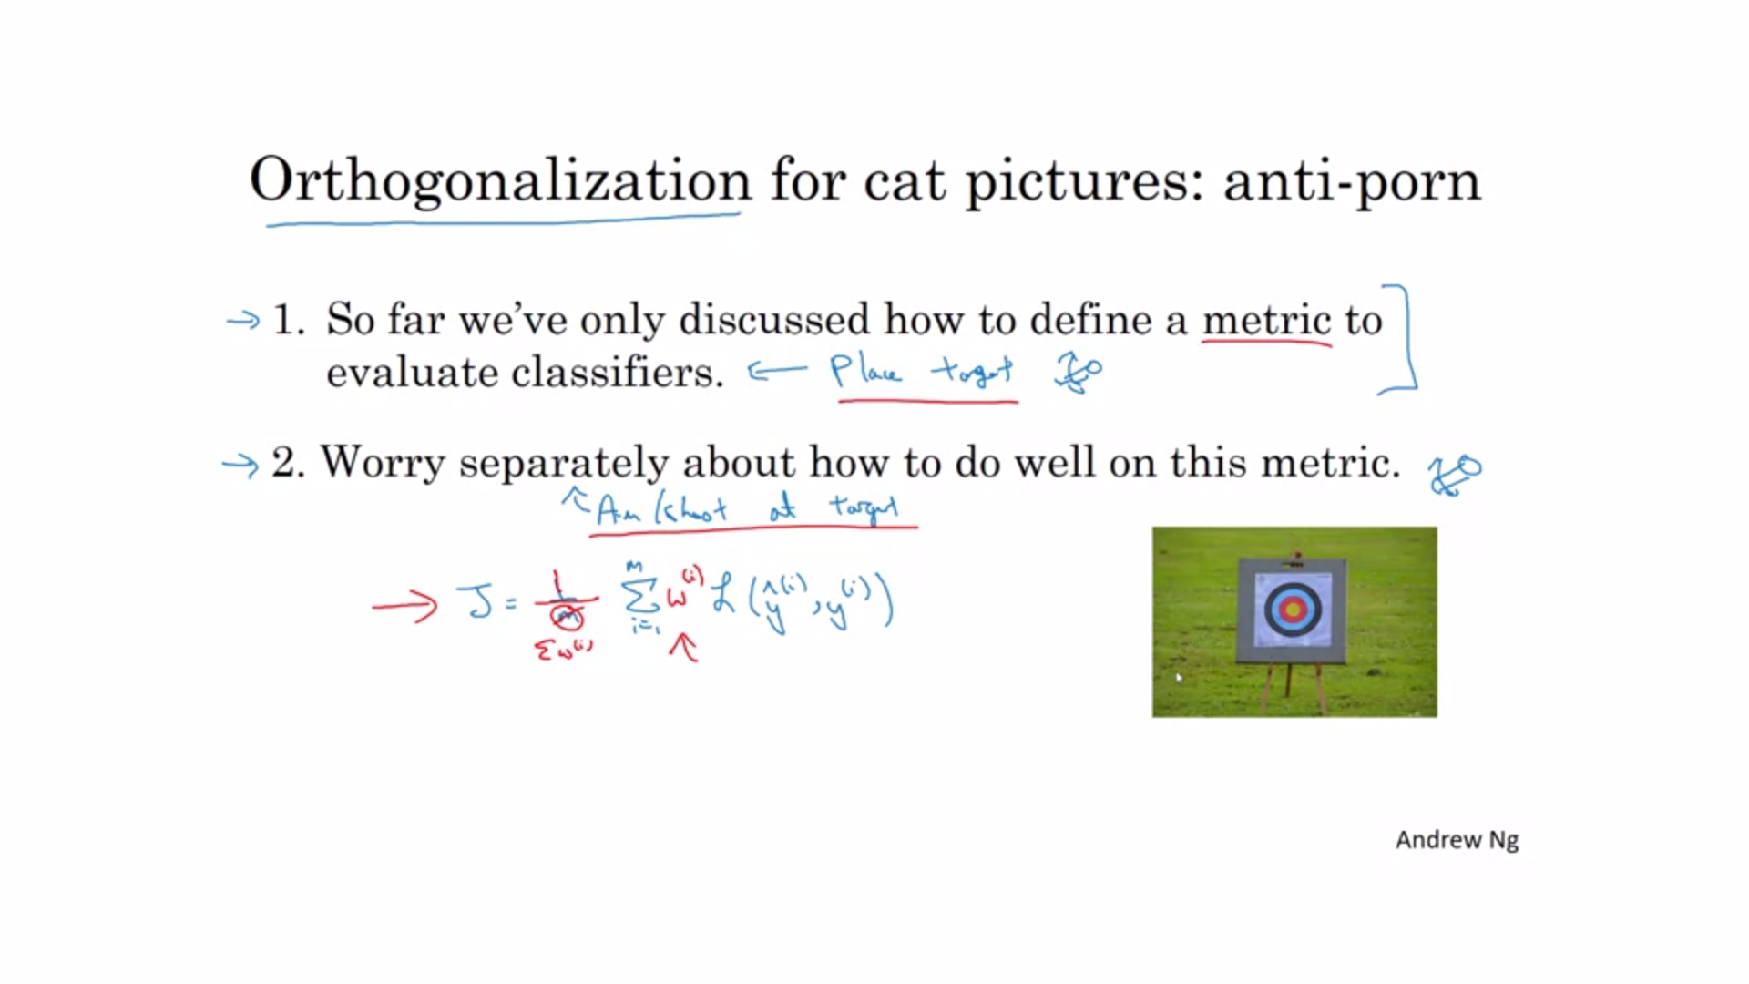

First step is to place the target. Second step is a separate problem: aim accurately at the target.

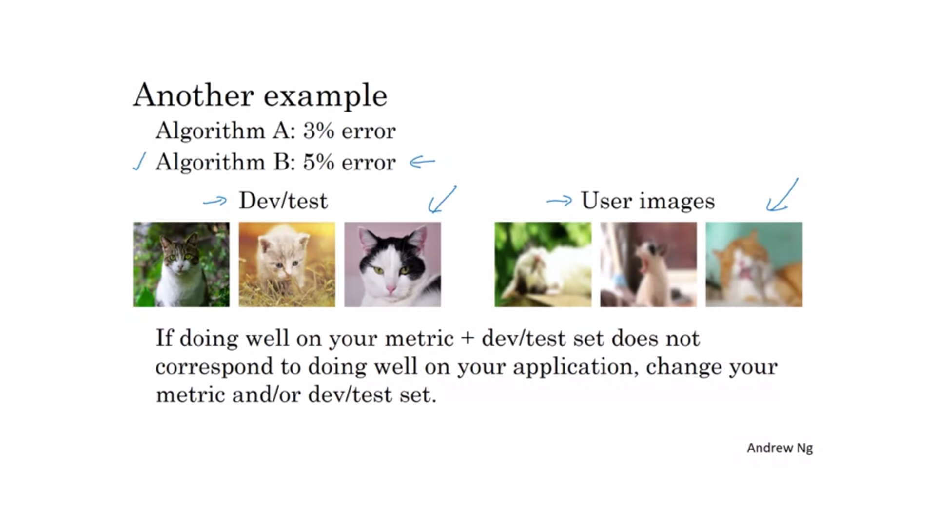

When deploying your algorithm you find that actually the one with the higher error is better.

You have been training on very nice high quality images but the users upload all kinds of images.

In the end it is important what kind of images the users upload.

Even if you cannot define the perfect metric, Andrew suggest to set something up quickly and then change it later.